Structural Biochemistry/Cell Organelles/Animal Cell
An animal cell is a type of eukaryotic cell that dominates most of the tissue cells in animals. Animal cells are different from plant cells because they lack cell walls and chloroplasts, which are pertinent to plant cells. Without the structure of a cell wall, animal cells can be a variety of shapes as they are instead surrounded by a plasma membrane. One thing that animal cells have exclusively that plant cells do not are centrioles. Centrioles are important for DNA segregation when the cell undergoes the process of mitosis, a process of dividing a cell. Centrioles are important in the structure of the spindles, which helps to pull the chromosomes apart.
Both animal and plant cells have vacuoles, however, in animal cells, vacuoles are very tiny or absent while the vacuole in plant cells are quite large.

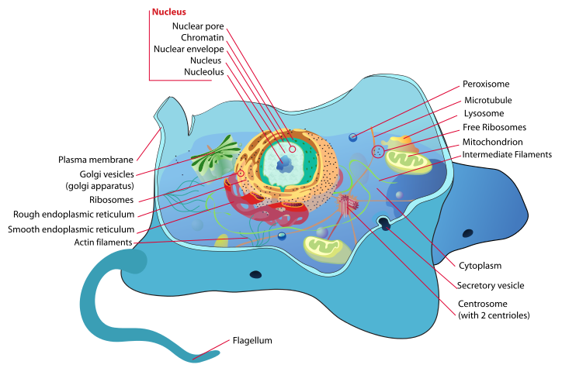

Cell Membrane:
The cell membrane is a fluid mosaic structure which is composed of a phospholipid bilayer and other important macromolecules such as proteins. The cell membrane separates the cell from the environment and allows the movement of materials in and out of the cell.
Cytoplasm:
The liquid within the cell where the different organelles are found. It is here where many functions occur. Including cell division and glycolysis.
Golgi Apparatus:
The organelle in which proteins are modified, sorted, and sent to various parts of the cell. Modifications on the protein include but are not limited to,glycosylation.
Mitochondria:
Does the cellular respiration of the cell by converting glucose into ATP (cellular energy).

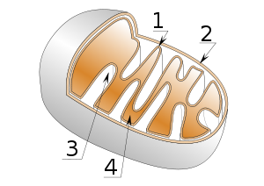
Mitochondria structure:
1) Inner membrane
2) Outer membrane
3) Crista
4) Matrix

Ribosome:
The mRNA from the nucleus are used by Ribosomes in a process called translation. Translation is when the Ribosome joins amino acids together according to the sequence of the mRNA. The more ribosomes in a cell, the proteins it synthesizes. They are located in two areas, on the ER or in the cytosol.
Rough Endoplasmic Reticulum:
Is used to store and transport material through the cell. Proteins are produced here in the ribosomes bound to the rough ER.
Smooth Endoplasmic Reticulum:
Functions in the synthesis of lipids, detoxification of drugs and poisons, storage of calcium ions, and metabolism of carbohydrates. In contrast to the Rough Endoplasmic Reticulum, the smooth ER is not studded with proteins.
Peroxisome:
A specialized metabolic compartment bounded by a single membrane. Additionally, it possesses enzymes that transfer hydrogen atoms from substrates to oxygen, producing hydrogen peroxide as a by-product. Then, hydrogen peroxide is converted to water by another enzyme.
Nucleus:
The nucleus is usually the largest organelle in a cell. It consists of different parts such as the nuclear envelope, chromosomes, and the nucleolus. The nuclear envelope surrounds the nucleus while segregating the chromatin from the cytoplasm and consists of two membranes each made of a lipid bilayer. The membranes have pores that regulate what goes in and out of the nucleus. Inside the nucleus is the nucleolus which holds the genetic material DNA. Using this DNA, transcription is carried out making mRNA.
Vacuole:
The "storage space" that stores water, salt, and other important substances. There are also food vacuoles that are cellular organelles in which food is broken down by hydrolytic enzymes. These food vacuoles are the simplest digestive compartments. The process of intracellular digestion occurs inside vacuoles, which is the process of hydrolysis of food. This process begins after a cell engulfs food materials through phagocytosis (solid food) or pinocytosis (liquid food).

Lysosome:
Considered the "digestion compartment" of the cell. Lysosomes break down cellular wastes such as fats, proteins, or carbohydrates. The rid of the cellular materials that are no longer useful in the cell.
Cytoskeleton:
Is a structure made out of protein to give the cell its shape and structure. It also helps cellular motion with the use of flagella, cilia, or lamelllipodia.
Centrioles:
Are used through cell division. They organize the mitotic spindle during the end of cytokinesis. The centrioles are located within the centrosome and come in pairs. Each pair of centrioles are compiled of nine sets of triplet microtubules assembled into a ring. Prior to animal cell division, the centrioles replicate. Although centrosomes with centrioles may assist the organization of microtubule construction in animal cells, they are not crucial for this particular function in all eukaryotes; e.g. the fungi and the majority of plant cells lack centrosomes with centrioles, but still contain well-assembled microtubules.

The Physiology of Internal membrane
Eukaryote cells include a variety of membrane-bound structures, collectively referred to as the endomembrane system. Simple compartments, called vesicles or vacuoles, can form by budding off other membranes. Many cells ingest food and other materials through a process of endocytosis, where the outer membrane invaginates and then pinches off to form a vesicle. It is probable that most other membrane-bound organelles are ultimately derived from such vesicles.
The nucleus is surrounded by a double membrane (commonly referred to as a nuclear envelope), with pores that allow material to move in and out. Various tube- and sheet-like extensions of the nuclear membrane form what is called the endoplasmic reticulum or ER, which is involved in protein transport and maturation. It includes the rough ER where ribosomes are attached to synthesize proteins, which enter the interior space or lumen. Subsequently, they generally enter vesicles, which bud off from the smooth ER. In most eukaryotes, these protein-carrying vesicles are released and further modified in stacks of flattened vesicles, called Golgi bodies or dictyosomes.
Vesicles may be specialized for various purposes. For instance, lysosomes contain enzymes that break down the contents of food vacuoles, and peroxisomes are used to break down peroxide, which is toxic otherwise. Many protozoa have contractile vacuoles, which collect and expel excess water, and extrusomes, which expel material used to deflect predators or capture prey. In higher plants, most of a cell's volume is taken up by a central vacuole, which primarily maintains its osmotic pressure.
